To: All Members of the Kettering Town Council Staffing Committee

You are requested to attend a meeting of the Kettering Town Council Staffing Committee on 13th April 2023 at 5pm in the KTC Office, Kettering Conference Centre.

The press and public are welcome to observe this meeting, but a place must be booked via the Town Clerk as spaces are limited.
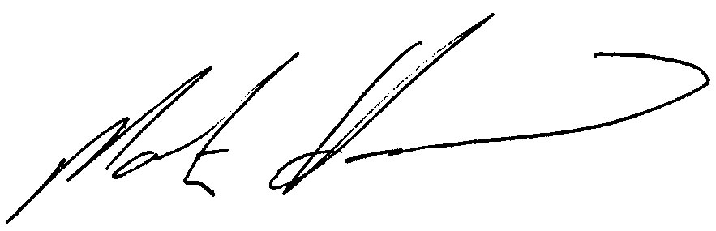

Martin Hammond
Town Clerk, Kettering Town Council

AGENDA

FC22/007 To receive and accept apologies for absence

FC22/008 Declarations of Interest

FC22/009 Agree minutes of last meeting held on 5th October 2023

FC22/010 Experimental Market Superintendent Role (attached report)

FC22/011 Employment Policies (attached reports)

- Lone working policy

- Health and safety policy

- Sick pay policy

